Design Challenge B: The Automobile

The invention of the automobile has since changed the way people around the world live and has affected many aspects such as family life, the environment and the economy and holds a direct correlation to the advancement of society.

When the first mass-produced automobile became publicly available in the 1920s, it quickly replaced other forms of transport such as the bike and the horse and carriage and the automobile’s popularity spread rapidly with ease as the term ‘Horseless carriage’ was used as it made the new vehicle compatible with the old vehicle but just without the need of a horse. The automobile enabled those living in suburbia to travel more conveniently and made for a more mobile society. What also contributed to the spreading of the automobile was its initial relative advantage as it was considered a luxury item in the beginning but became more affordable as they became more mass produced. As a result, producers such as Ford lowered the cost of the manufacturing process in order to make their cars more widely available to the public.

Its simplicity and ease of use also led to its spreading as teenagers of the age of 16/17 are eligible to drive. The observable results of the automobile seemed obvious as it was an improvement on the already established forms of transport. Additionally, the automobile facilitated another value of leisure, as car enthusiasm became more popular each passing year as people began to take pride in the speed and the aesthetic of their automobile.

The development of the automobile has seen massive growth, but it also comes with its issues. Manufacturers put immense emphasis on the safety aspects of the car due to the numerous accidents that accumulate every year. Additionally, the rising issue of global warming has become a concern and therefore companies like Tesla are trying to combat this with the development of the electric car and companies are introducing hybrid models to cut down their use of gasoline.

Words: 330

[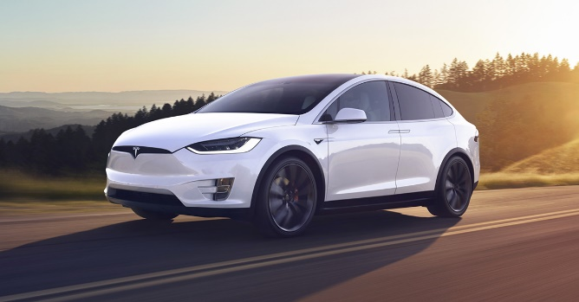](https://www.google.co.uk/url?sa=i&rct=j&q=&esrc=s&source=images&cd=&ved=2ahUKEwiq3LypzKfhAhVRJhoKHUacDlgQjRx6BAgBEAU&url=https%3A%2F%2Fwww.tesla.com%2Fmodelx&psig=AOvVaw1HOjNgVLU68BGQ9naQHkA2&ust=1553957324909695)[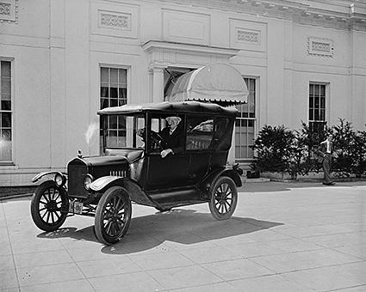](https://www.google.co.uk/url?sa=i&rct=j&q=&esrc=s&source=images&cd=&cad=rja&uact=8&ved=2ahUKEwixsezQy6fhAhVMxhoKHe0BC04QjRx6BAgBEAU&url=https%3A%2F%2Fcars.lovetoknow.com%2FFirst_Automobile_Made&psig=AOvVaw2n0wMBWo52RokRkGQAQ1Qk&ust=1553957125429302)